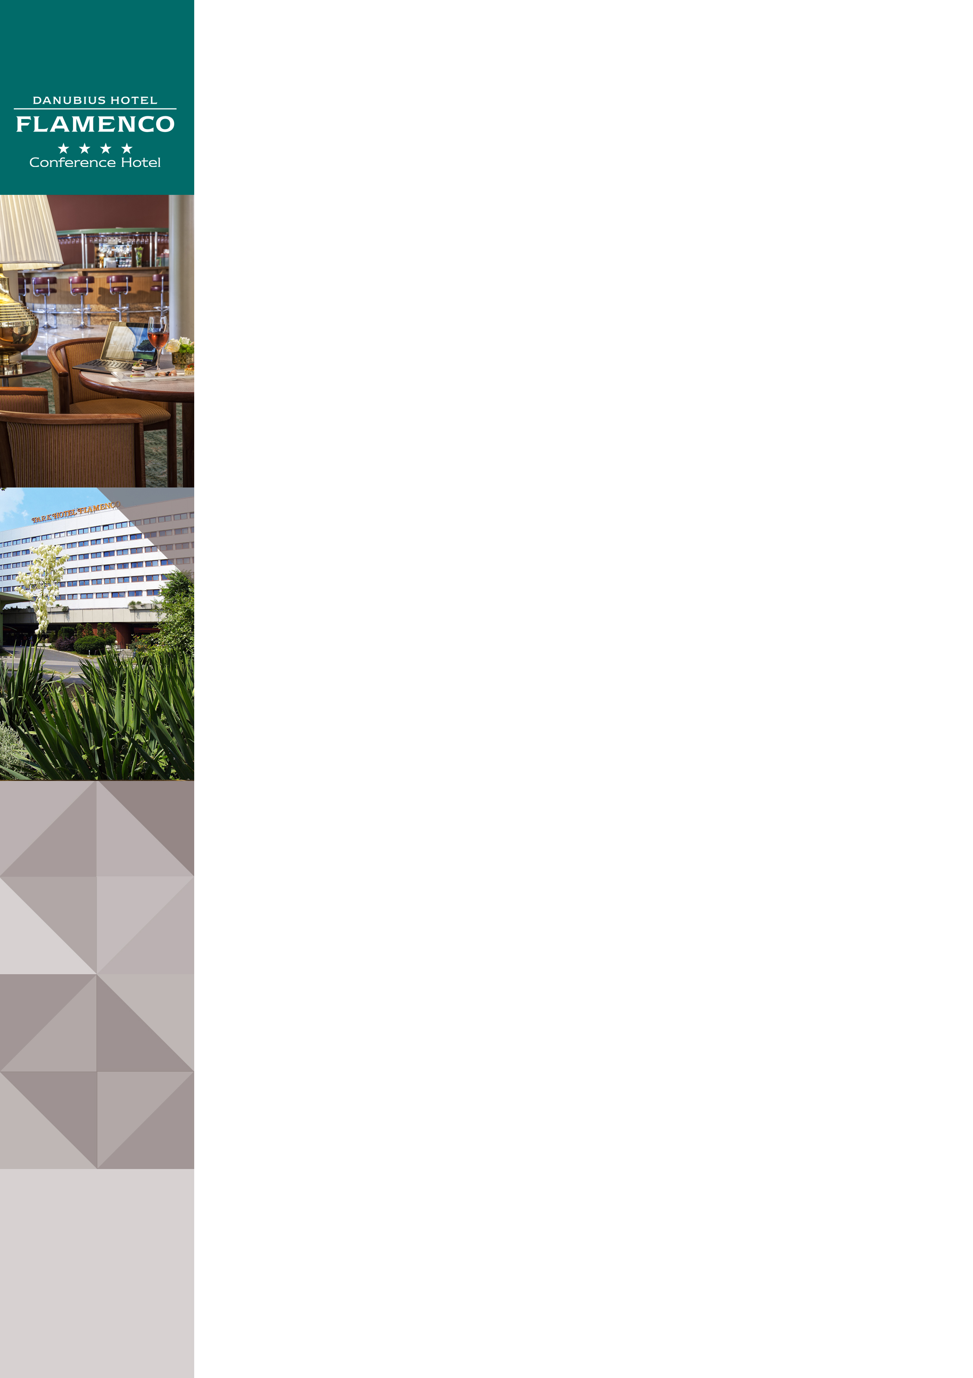Danubius Hotel Flamenco in Budapest

Address: |  | Danubius Hotel Flamenco****, Tas vezér utca 3-7, 1113 Budapest, Hungary
Website |  | www.danubiushotels.com/flamenco
Target group(s) |  | City travellers
Special features |  | Set in calm surroundings, at a small park on the Buda side
Star-based rating |  | **** 4 stars
Year of construction/latest renovation |  | 1983/ continuous
CONTACT
E-mail |  | flamenco.reservation@danubiushotels.com
Reception phone number |  | +36 1 889 5600
Point of contact in the case of problems |  | +36 1 889 5600
OVERVIEW
WiFi |  | Free in the entire hotel.
Reception opening hours |  | 0 – 24
Location |  | - from Liszt Ferenc airport, 45 minutes by taxi (22 km)  - from Budapest-Keleti railway station, 20 minutes by taxi (7 km)
Distance from Budapest city centre |  | 10 minutes (3 km) by taxi, bus or tram as well as via M4 metro from Móricz Zsigmond square
Public transport |  | - bus stop (Bus 7) 5 minutes on foot  - metro station (M4) 5 minutes on foot
Parking |  | - The hotel's dedicated parking garage: 3600 HUF/day  - Roof parking facility: 1900 HUF/day
Pets are welcome |  | Yes, EUR 20 per night
Currency exchange |  | No
Car and bike rental |  | No  The MOL BUBI community bicycle system is just a stone's throw away. http://molbubi.bkk.hu/
ROOMS
Total number of rooms |  | 355
Single rooms (included DR for single use) |  | 355
Rooms for disabled guests |  | Yes, 2 rooms
Anti-allergy rooms |  | No
Non-smoking rooms |  | Yes
Check-in & Check-out |  | Check-in time: 14:00  Check-out time: 12:00
Hotel rooms
Category 1 | Economy Double Room: 20 m² room with a double bed or twin beds overlooking the hill or the park. An extra bed can be provided in some of the rooms.  Some of the economy rooms have been transformed into green rooms.  Room amenities: air conditioning, bathroom with bathtub, hair dryer, TV with cable channels, radio, telephone, minibar, safe.
Category 2 | Danubius Guestroom: 20 m² room with a double bed or twin beds overlooking the hill or the park. An extra bed can be provided in some of the rooms.  Room amenities: air conditioning, bathroom with bathtub, hair dryer, TV with cable channels, radio, telephone, minibar, safe deposit box.
Category 3 | Executive Double Room: 20 m² room with a double bed or twin beds overlooking the hill or the park. An extra bed can be provided in some of the rooms.  Breakfast possibility in the Executive Lounge.  Room amenities: air conditioning, bathroom with bathtub, hair dryer, TV with cable channels, radio, telephone, minibar, tea /coffee in room, safe deposit box.
Category 4 | Suite: 59 m² suite with a separate living room and bedroom with double bed, overlooking the park. The living room can be turned into a second bedroom.  Room amenities: air conditioning, bathroom with bathtub, hair dryer, TV with cable channels, radio, telephone, minibar, safe deposit box, tea /coffee in room.
SPA & WELLNESS
Spa opening hours: | Mon - Fri 7:00 - 22:00  Sat - Sun 8:00 - 20:00
Facilities: | - Indoor swimming pool  - Sauna  - Solarium  - Fitness room
Services | Massages, beauty treatments, dental clinic, hairdresser
DINING
Units/ opening hours | - Columbus Coffee Shop (Mon-Sat 12:00 – 23:00, Sun 15:00-23:00)  - Flamenco Terrace: in summer time only,  12:00 - 23:00  - Lobby Bar (8:00 – 24:00), live piano music in the afternoons
Vegetarian/vegan dishes |  | Yes
Low-fat dishes |  | Yes
MEETINGS
Meeting and conference rooms |  | 16 air-conditioned conference and function rooms with seating capacities of up to 500 guests.

