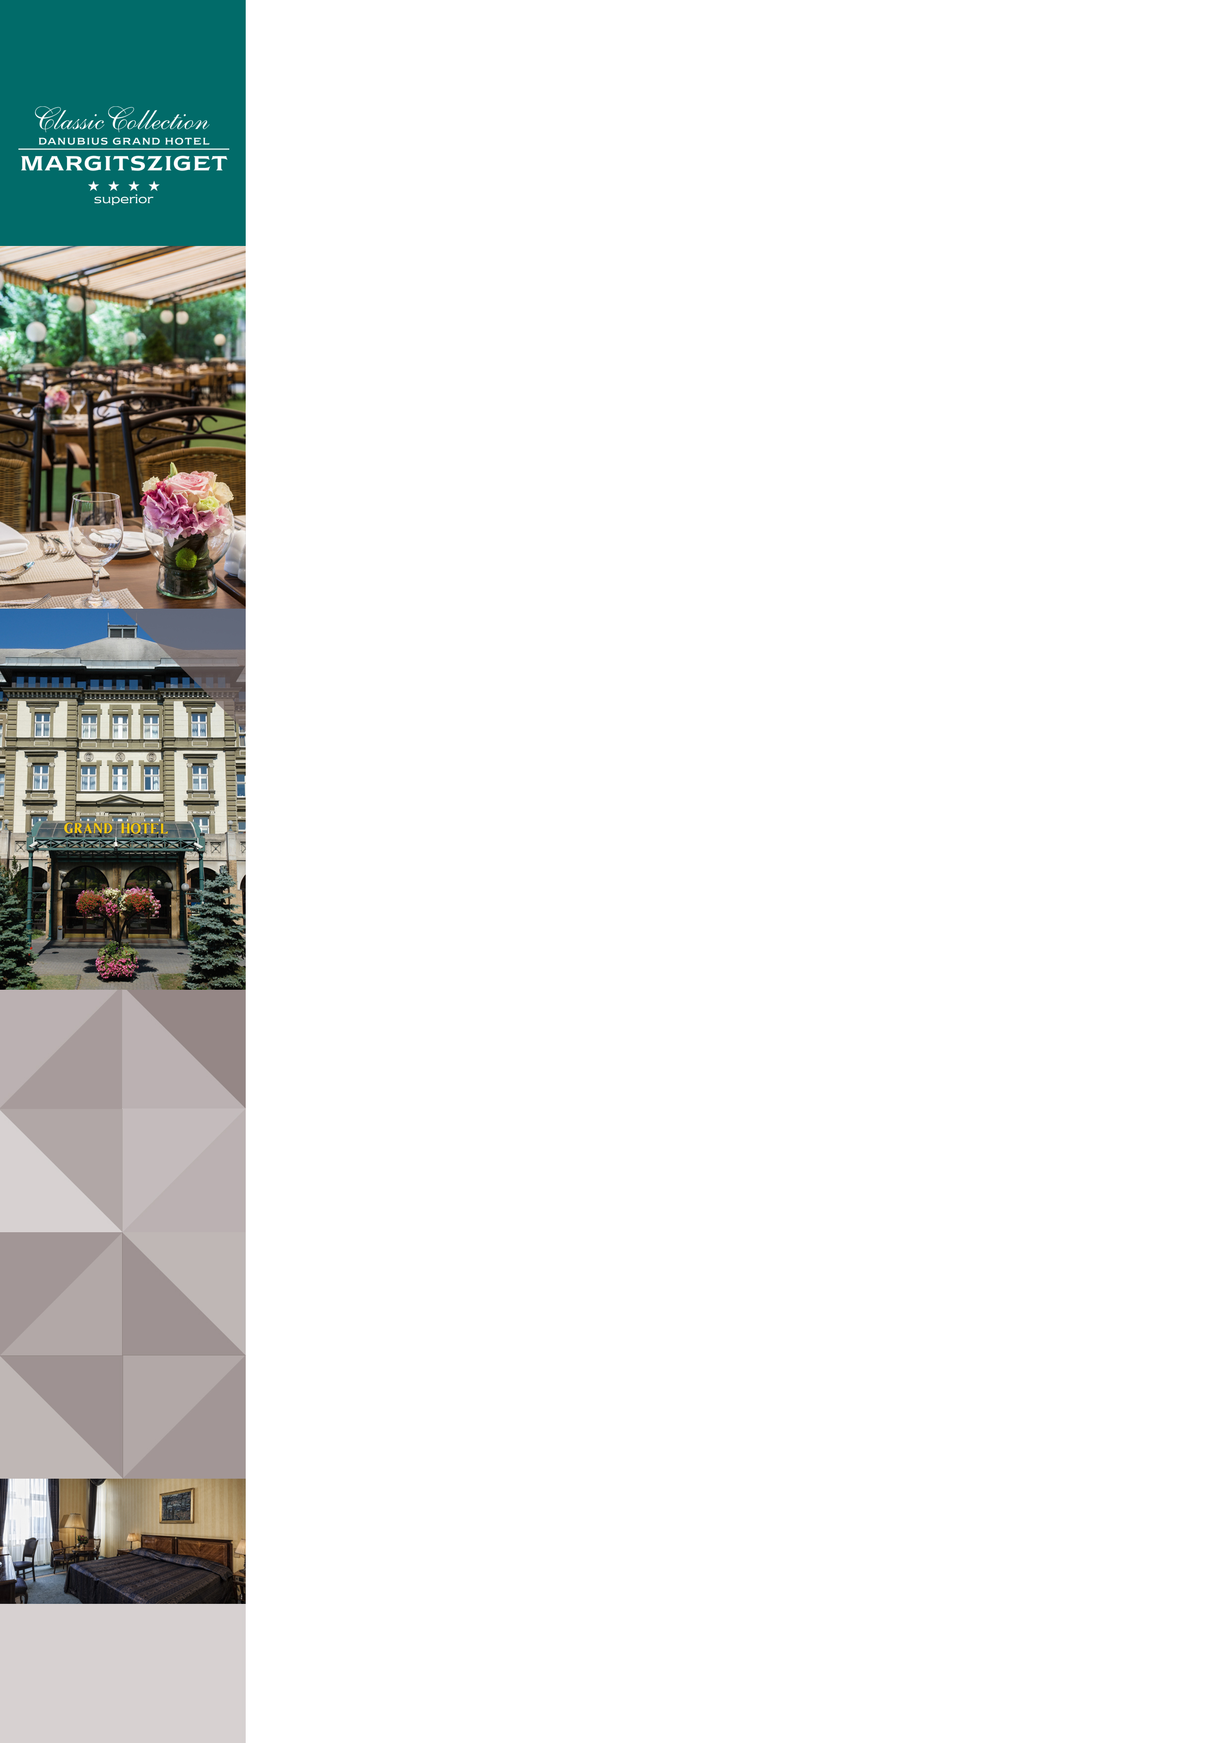Danubius Grand Hotel Margitsziget in Budapest

Address: |  | Danubius Grand Hotel Margitsziget **** Superior, 1007 Budapest, Hungary
Website |  | http://www.danubiushotels.com/grandhotel
Target group(s) |  | City travellers
Special features |  | - Located in a tranquil spot on Margaret Island  - Connected to the neighbouring  Danubius Health Spa Resort Margitsziget by a heated underground corridor
Star-based rating |  | **** 4 stars Superior
Year of construction/latest renovation |  | 1873 / 2016
CONTACT
E-mail |  | msz.reservation@danubiushotels.com
Reception phone number |  | +36 1 889 4700
Point of contact in the case of problems |  | Mrs. Noemi Gabeli
OVERVIEW
WiFi |  | Free in the entire hotel.
Reception opening hours |  | 0 – 24
Location |  | - from Liszt Ferenc airport, 45 minutes by taxi (28 km)  - from Budapest-Nyugati railway station, 15 minutes by taxi (5 km)  - from Budapest-Keleti railway station, 25 minutes by taxi (9 km)
Distance from Budapest city centre |  | The city centre is15 minutes by taxi (5 km)
Public transport |  | - The Szállodák bus station (Bus 26) is 3 minutes on foot (220 meters)
Parking |  | - Open-air parking subject to fee (EUR 8 ; HUF 2400 / car / day  - Parking garage subject to fee (EUR 13.3 ; HUF 4000) / car / day- Please note. Please provide the license plate number to the hotel in advance and press the HOTEL button when entering the parking garage in order to benefit from discounted parking!
Pets are welcome |  | Yes, EUR 20 per night
Currency exchange |  | Yes
Car and bike rental |  | Car rental, bicycle rental
Sports and leisure facilities |  | On Margaret Island: Jogging path, tennis courts, rowing boats, bicycle rental, Nordic Walking, table tennis, darts
ROOMS
Total number of rooms |  | 164
Single rooms (included DR for single use) |  | 164
Rooms for disabled guests |  | No
Anti-allergy rooms |  | Yes (2 rooms)
Non-smoking rooms |  | Yes
Check-in & Check-out |  | Check-in time: 14:00  Check-out time: 12:00
Hotel rooms
Category 1 | Danubius Guestroom: 15m² twin or double room overlooking the park or the Danube.  Room amenities: air conditioning, LCD TV, pay-per-view channels, cable channels, radio, bathroom with bathtub, toilet, tea/coffee maker, safe deposit box, telephone, minibar, hair dryer, wake up call, bathrobe, balcony in some of the rooms, room service.
Category 2 | Deluxe Double Room: 24m² twin or double room overlooking the park or the Danube.  Room amenities: air conditioning, LCD TV, pay-per-view channels, cable channels, bathroom with bathtub/ some with shower, tea/coffee maker, safe deposit box, telephone, minibar, hair dryer, wake up call, bathrobe, balcony in some of the rooms, room service.
Category 3 | Suite: 40m² suite with a living room and twin or double bedded sleeping room  Room amenities: air conditioning, 2 LCD TVs, pay-per-view channels, cable channels, radio, bathroom with bathtub/ some with shower and bidet as well, tea/coffee maker, safe deposit box, telephone, minibar, hair dryer, wake up call, bathrobe, balcony in some of the rooms, room service.
Category 4 | Family room: 24m² rooms with two double beds overlooking the park or the Danube. Ideal for families.  Room amenities: air conditioning, LCD TV, pay-per-view channels, cable channels, radio, bathroom with bathtub, tea/coffee maker, safe deposit box, telephone, minibar, hair dryer, wake up call, bathrobe, balcony in some of the rooms, room service.
Category 5 | Deluxe Suite: 47m² suite with a living room and a twin bedded sleeping room overlooking the park.  Room amenities: air conditioning, 2 LCD TVs, pay-per-view channels, cable channels, radio, bathroom with and shower and bidet as well, tea/coffee maker, safe deposit box, telephone, minibar, hair dryer, wake up call, bathrobe, balcony in some of the rooms, room service.
SPA & WELLNESS | All facilities are located at the neighbouring Danubius Health Spa Resort Margitsziget and can be used by Grand Hotel guests.
Thermal water | - From the hotel's own thermal spring, with high calcium, magnesium,  hydrogen carbonate, sulphur and chloride content  - Indications:  rheumatic diseases of the locomotive system,  arthritis, gout, polyarthritis, ankylosing spondylarthritis, lower back  pain, frozen shoulder, post injury and post operative rehabilitation of joints and spine, fibromyalgy, nervous disorders, geriatric regeneration.
Spa opening hours: | Mon - Sun 6:30 - 21:30
Facilities/  water temperature | - Thermal bath (37-38°C)  - Indoor (27-28°C) and outdoor swimming pools (26-27°C)  - Adventure pool (32-34°C)  Thermal water pool with underwater exercise (33-35°C)  - Gymnastics pool (34-36°C)  - Sauna, Infra-sauna  - Steam cabin  - Aroma cabin  - Solarium  - Sun terrace  - Salt cave  - Fitness centre
Services | - Own medical and health spa centre  - Hydrotherapy, balneotherapy, physiotherapy  - Cardio centre  - Dental clinic  - Laser eye clinic  - Cosmetic surgery  - Dietary consulting  - Wellness treatments  - Beauty treatments  - Fitness group exercise
Special features | Ladies’ Hour Ladies can use the thermal pools exclusively for one hour 3 times a week:  Monday/Wednesday/Friday 12:00-13:00
DINING
Units/ opening hours | Széchenyi Restaurant (7:00 - 10:00, 12:00 - 15:00,  19:00 - 23:00) Reservations: + 36 1 889-4700  - Live gypsy music (except on Monday)  - Garden terrace  - Grill Terrace  - Begonia Café and Terrace  - Brasserie  - Victoria Drink Bar
Vegetarian/vegan dishes | Yes
Low-fat dishes | Yes
MEETINGS
Meeting and conference rooms | The hotel, in combination with the facilities of the neighbouring Health Spa Resort Margitsziget, offers outstanding meeting, banquet and conference facilities for up to 300 guests, in 14 multi-size function rooms.
AWARDS
tripadvisor | Certificate of Excellence 2015 Winner

