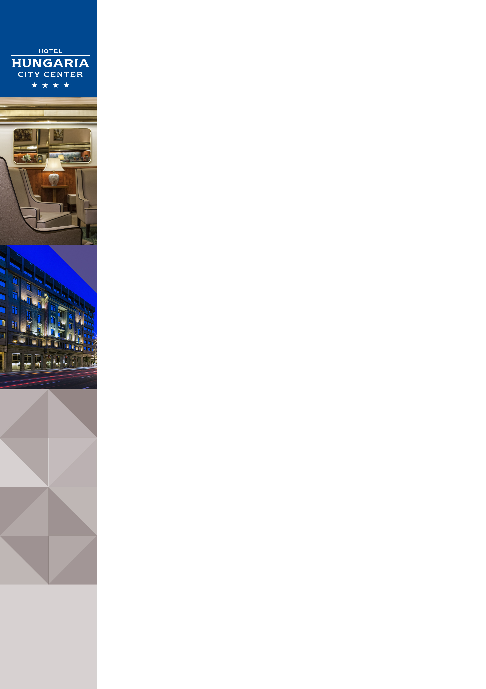Hotel Hungaria City Center in Budapest

Address: |  |  | Hotel Hungaria City Center ****, Rákóczi út 90, 1074 Budapest, Hungary
Website |  |  | www.danubiushotels.com/hungaria
Target group(s) |  |  | - City travellers  - Business travellers
Special features |  |  | The biggest hotel in Budapest
Star-based rating |  |  | **** 4 stars
Year of construction/latest renovation |  |  | 1915 / 2013 (Lobby)
CONTACT
E-mail |  |  | hungaria.booking@danubiushotels.com
Reception phone number |  |  | +36 1 8894460
Point of contact in the case of problems |  |  | Mrs. Dora Molnar
Conference centre phone number |  |  | +36 1 8894531
OVERVIEW
WIFI |  |  | Free in the entire hotel.
Reception opening hours |  |  | 0 – 24
Location |  |  | - from Liszt Ferenc airport, 30 minutes by taxi (16 km)  - 2 minutes on foot from Budapest-Keleti railway station
Distance from Budapest city centre |  |  | The city centre is 3 minutes by taxi (2 km)
Public transport |  |  | - 5 minutes on foot from Budapest-Keleti railway station  - bus stop in front of the hotel
Parking |  |  | - The hotel's dedicated parking garage: EUR 16 per night  - Previous reservation is required
Pets are welcome |  |  | Yes, EUR 20 / pet per night
Currency exchange |  |  | Yes
Car and bike rental |  |  | Car rental
ROOM
Total number of rooms |  |  | 468
Double rooms (included DR for single use) |  |  | 365
Rooms for disabled guests |  |  | No
Anti-allergy rooms |  |  | No
Non-smoking rooms |  |  | Yes
Hotel rooms
Category 1 | Standard Double Room: 22 m² double bedded room overlooking the street or the courtyard.  Room amenities: air conditioning, bathroom with bath/shower, hair dryer, TV with cable channels, telephone, refrigerator, wake up call Safe deposit box, minibar and tea/coffee maker on request.
Category 2 | Standard Twin Room: 22 m² twin bedded room overlooking the street or the courtyard.  Room amenities:soundproof windows, air conditioning, bathroom with bath/shower, hair dryer, TV with cable channels, telephone, refrigerator, wake up call  Safe deposit box, minibar and tea/coffee maker on request.
Category 3 | Standard Single Room: 13 – 16 m² room with a single bed overlooking the street or the courtyard.  Room amenities: soundproof windows, air conditioning, bathroom with bath/shower, hair dryer, TV with cable channels, telephone, refrigerator, wake up call Safe deposit box, minibar and tea/coffee maker on request.
Category 4 | Standard Triple Room: 27 – 30 m² room with three beds overlooking the street or the courtyard.  Room amenities: soundproof windows, air conditioning, bathroom with bathtub, hair dryer, TV with cable channels, telephone, refrigerator. Safe deposit box, minibar and tea/coffee maker on request.
Category 5 | Junior Suite: 28 – 31 m² suite with a separate bedroom and living room overlooking the courtyard.  Room amenities: soundproof windows, air conditioning, bathroom with bathtub, hair dryer, TV with cable channels, telephone, refrigerator, safe deposit box. Minibar and tea/coffee maker on request.
DINING
Units/ opening hours |  | - Beatrix Restaurant (6:30 - 10:00, 12:00 - 14:00, 18:00 - 23:00)  - Fiaker Restaurant (12:00 - 23:00)  - Lobby Bar (8:00 – 24:00)
Vegetarian/  vegan dishes |  | No
Low-fat dishes |  | No
MEETINGS
Meeting and conference rooms |  | 12 conference and function rooms of various sizes with seating capacities of up to 500 people.

