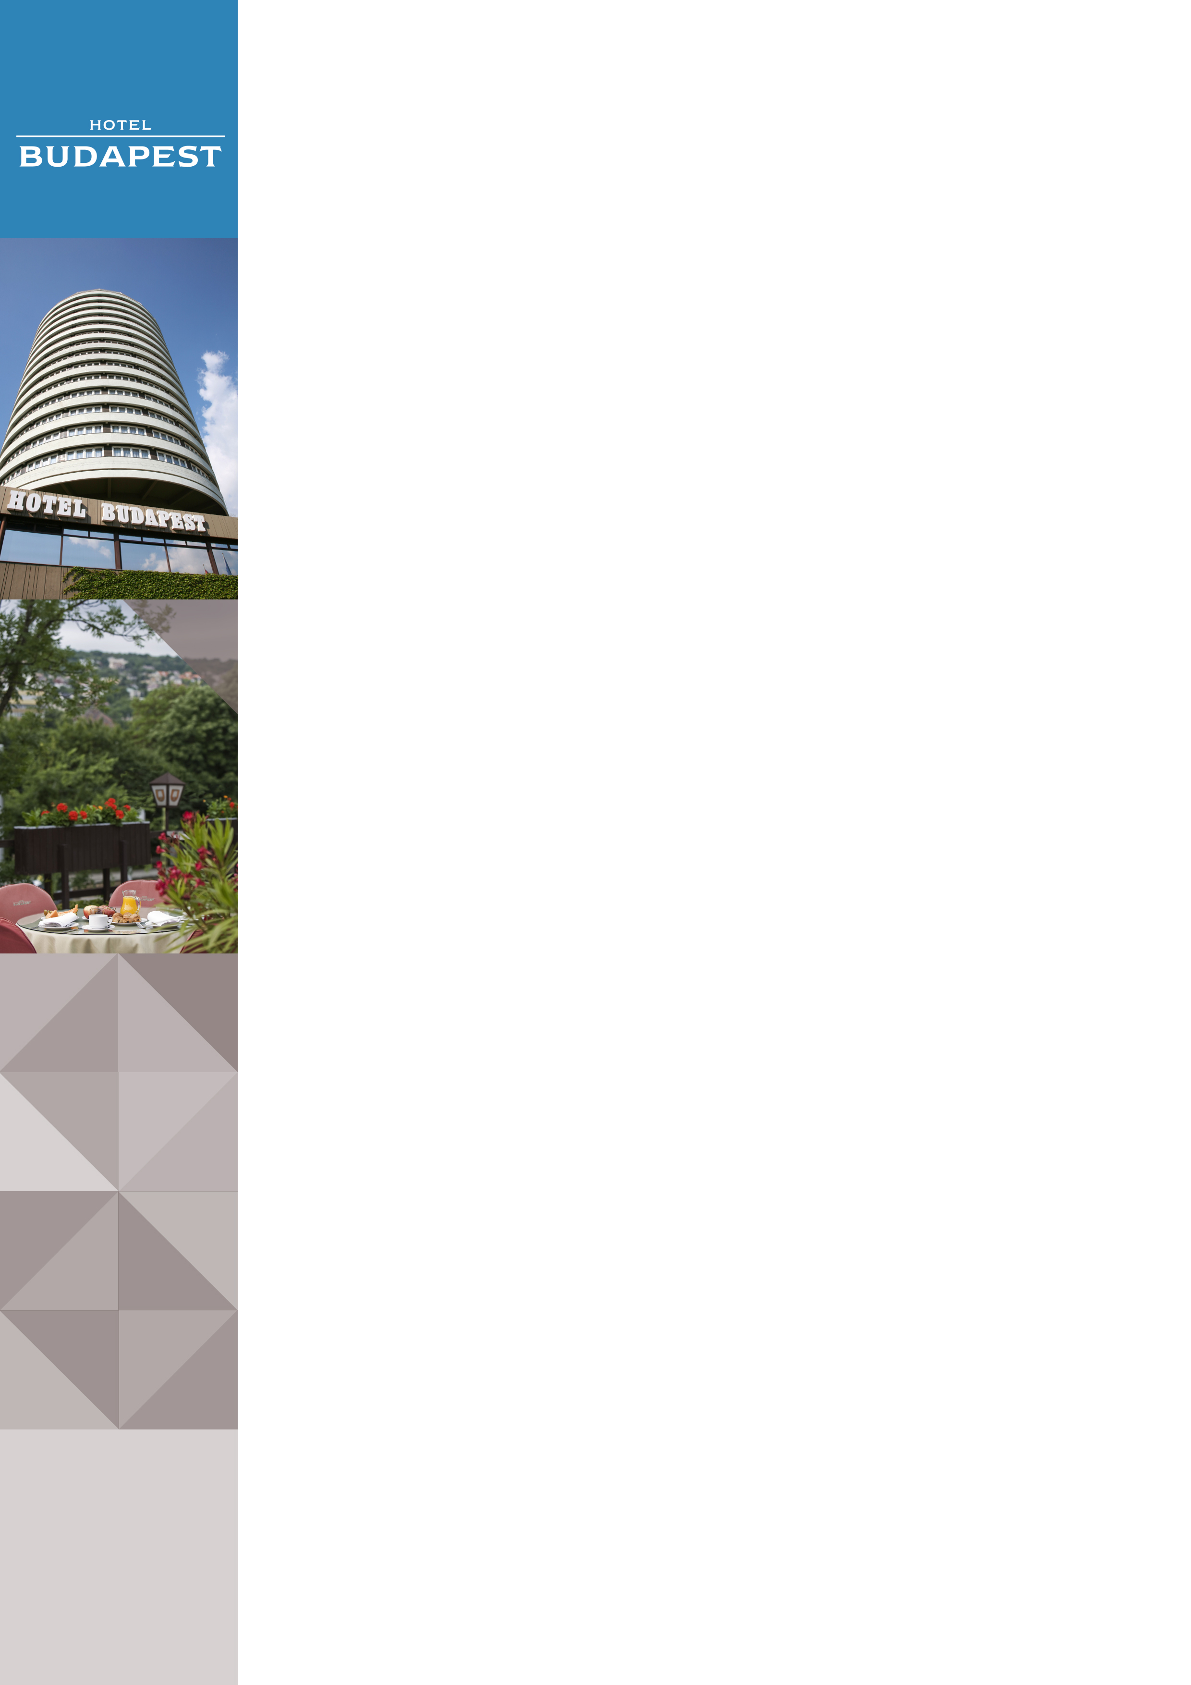Hotel Budapest in Budapest

Address: |  | Hotel Budapest****, Szilágyi Erzsébet fasor 47, 1026 Budapest, Hungary
Website |  | www.danubiushotels.com/hotelbudapest
Target group(s) |  | City travellers
Special features |  | 360-degree panoramic views thanks to the round-shaped design of the building
Star-based rating
Year of construction/latest renovation |  | 1967 /1997
CONTACT
E-mail |  | budapest.reservation@danubiushotels.com
Reception phone number |  | +36 1 889 4200
Point of contact in the case of problems |  | + 36 1 889 4200
OVERVIEW
WiFi |  | Free in the entire hotel.
Reception desk opening hours |  | 0 – 24
Location |  | - from Liszt Ferenc airport, 50 minutes by taxi (25 km)  - from Budapest-Keleti railway station, 40 minutes by taxi (10 km)
Distance from Budapest city centre |  | 20 minutes (3 km) with public transportation
Public transport |  | - bus stop (Bus 5) immediately in front of the hotel  - tram stop (Tram 61) immediately in front of the hotel
Parking |  | Parking lot in front of the hotel:  3000 HUF per night per car
Pets are welcome |  | Yes, EUR 20 per day
Currency exchange |  | No
Car and bike rental |  | No
ROOMS
Total number of rooms |  | 289
Single rooms (included DR for single use) |  | 289
Rooms for disabled guests |  | No
Anti-allergy rooms |  | No
Non-smoking rooms |  | Yes
Check-in & Check-out |  | Check-in time: 14:00  Check-out time: 12:00
Hotel rooms
Category 1 | Standard Double Room:20,4 m² double or twin bedded rooms with panoramic views. An extra bed can be provided in some of the rooms.  Room amenities:: air conditioning, bathroom with bathtub, hair dryer, TV with cable channels, radio, telephone.
Category 2 | Superior Double Room: 20,4 m² double or twin bedded rooms on the 12th, 13th and 14th floors with panoramic views. An extra bed can be provided in some of the rooms.  Room amenities:: air conditioning, bathroom with bathtub, hair dryer, TV, cable channels, telephone, minibar, safe deposit box in all of the rooms.
Category 3 | Junior Suite: 40,8 m² suite with a living room and a bedroom.The living room can be turned into a second bedroom.  Room amenities:: air conditioning, bathroom with bathtub, hair dryer, extra toilet, TV with cable channels, radio, telephone, minibar, safe deposit box, electric kettle.
DINING
Units/ opening hours |  | - Restaurant Budapest (7:00 - 10:00, 12:00 - 15:00, 18:00 - 22:00)  - Summer terrace  - Café (10:00 – 24:00)
Vegetarian/vegan dishes |  | Yes
Low-fat dishes |  | Yes
MEETINGS
Meeting and conference rooms |  | 4 function rooms with seating capacities of 25-150 guests.

