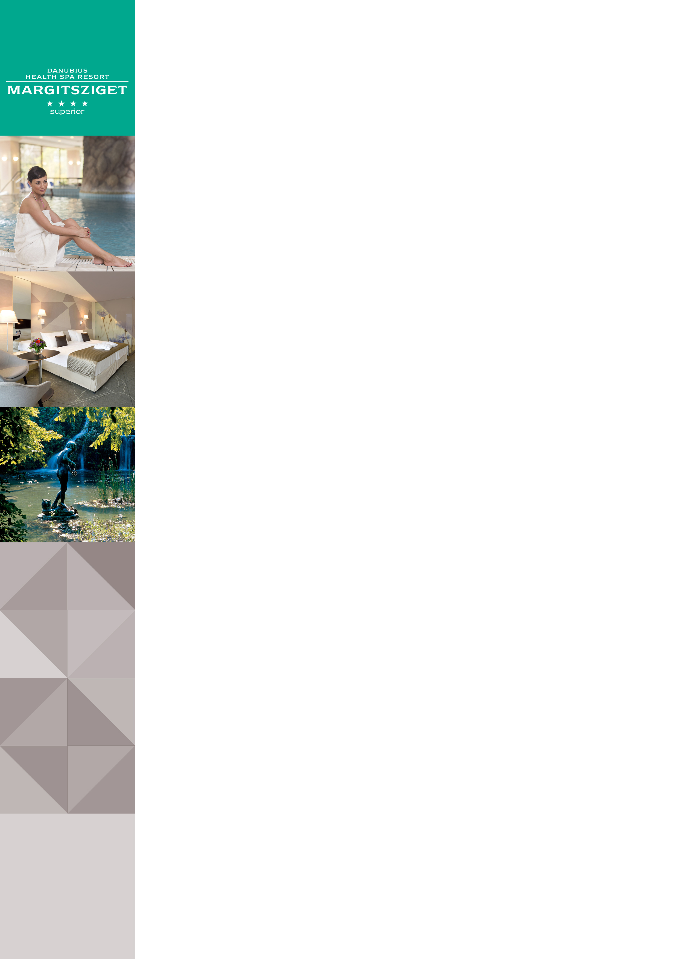Danubius Health Spa Resort Margitsziget in Budapest

Address: |  | Danubius Health Spa Resort Margitsziget **** Superior, 1007 Budapest, Hungary
Website |  | www.danubiushotels.com/margitsziget
Target group(s) |  | - City travellers  - Medical tourists and wellness guests
Special features |  | - Located in a tranquil spot on Margaret Island  - Hotel with own medical and wellness centre  - Outdoor swimming pools
Star-based rating |  | **** 4 stars Superior
Year of construction/latest renovation |  | 1979 / 2017
CONTACT
E-mail |  | msz.reservation@danubiushotels.com
Reception phone number |  | +36 1 889 4700
Point of contact in the case of problems |  | Mrs. Noemi Gabeli
Spa department phone number: |  | +36 1 889 4737
Conference centre phone number |  | +36 1 889 4722
OVERVIEW
WiFi |  | Free in the entire hotel.
Reception opening hours |  | 0 – 24
Location |  | - from Liszt Ferenc airport, 45 minutes by taxi (28 km)  - from Budapest-Nyugati railway station, 15 minutes by taxi (5 km)  - from Budapest-Keleti railway station, 25 minutes by taxi (9 km)
Distance from Budapest city centre  . |  | The city centre is15 minutes by taxi (5 km)
Public transport |  | - The Szállodák bus station (Bus 26) is 3 minutes on foot (220 meters)
Parking |  | - Open-air parking subject to fee (EUR 8, HUF 2400 / car / day  - Parking garage subject to fee (EUR 13,3, HUF 4000) / car / day  - Please note. Please press the HOTEL button when entering the parking garage in order to benefit from discounted parking!
Pets are welcome |  | Yes, EUR 20 per day
Currency exchange |  | Yes
Car and bike rental |  | Car rental, bicycle rental
Sports and leisure facilities |  | On Margaret Island: Jogging path, tennis courts, rowing boats, bicycle rental, table tennis, darts, Nordic Walking.
ROOMS
Total number of rooms |  | 281
Single rooms (included DR for single use) |  | 281
Rooms for disabled guests |  | Yes (4 rooms)
Anti-allergy rooms |  | No
Non-smoking rooms |  | All rooms are Non-smoking
Check-in & Check-out |  | Check-in time: 14:00;  Check-out time: 12:00
Hotel rooms
Category 1 | Standard room: 18m² twin or double room overlooking the park or the Danube. An extra bed can be provided in the room.  Room amenities: air conditioning, LCD TV, pay-per-view channels, cable channels, radio, bathroom with bathtub, tea/coffee maker, safe deposit box, telephone, minibar, hair dryer, wake up call, bathrobe, balcony, room service.
Category 2 | Family Room: 24m² room with two double beds overlooking the park or the Danube. Ideal for families.  Room amenities: air conditioning, LCD TV, pay-per-view channels, cable channels, radio, bathroom with bathtub, tea/coffee maker, safe deposit box, telephone, minibar, hair dryer, wake up call, bathrobe, balcony, room service.
Category 3 | Premium Double Room: 18m² fully renovated twin or double room overlooking the park or the Danube.  Room amenities: air conditioning, LCD TV, radio, pay-per-view channels, cable channels, bathroom with walk-in shower, tea/coffee maker, safe deposit box, telephone, minibar, hair dryer, wake up call, bathrobe, balcony, room service,
Category 4 | Executive Twin Room: 18m² room with two beds overlooking the Danube.  Room amenities: air conditioning, LCD TV, pay-per-view channels, cable channels, radio, bathroom with bathtub, toilet, tea/coffee maker, safe deposti box, telephone, minibar, hair dryer, wake up call, bathrobe, balcony, room service, slippers. Breakfast possibility in the Executive Lounge.
Category 5 | Executive Junior Suite: 24m² twin or double room, overlooking the Danube.  Room amenities: air conditioning, LCD TV, pay-per-view channels, cable channels, radio, bathroom with bathtub, shower, separate toilet, tea/coffee maker, safe deposit box, telephone, minibar, hair dryer, wake up call, bathrobe, balcony, room service. Breakfast possibility in the Executive Lounge.
Category 6 | Executive Suite: 40m² suite with spacious living room and twin or double bedded sleeping room overlooking the Danube.  Room amenities: air conditioning, 2 LCD TVs, pay-per-view channels, cable channels, radio, bathroom with bathtub, shower, toilet and bidet, tea/coffee maker, safe deposit box, telephone, minibar, hair dryer, wake up call, bathrobe, balcony, room service. Breakfast possibility in the Executive Lounge.
SPA & WELLNESS
Thermal water | - From the hotel's own thermal spring, with high calcium, magnesium, hydrogen carbonate, sulphur and chloride content  - Indications:  Rheumatic diseases of the locomotive system, arthritis, gout, polyarthritis, ankylosing spondylarthritis, lower back pain, frozen shoulder, post injury and post operative rehabilitation of joints and spine nervous disorders, geriatric regeneration.
Spa opening hours: |  | Mon - Sun 6:30 - 21:30
Facilities / water temperature |  | - Thermal bath (37-38°C)  - Indoor (27-28°C) and outdoor swimming pools (26-27°C)  - Adventure pool (32-34°C)  Thermal water pool with underwater exercise (33-35°C)  - Gymnastics pool (34-36°C)  - Sauna  - Infra-sauna  - Steam cabin  - Aroma cabin  - Solarium  - Sun terrace  - Salt cave  - Fitness centre
Services |  | - Own medical and health spa centre  - Hydrotherapy, balneotherapy, physiotherapy  - Cardio centre  - Dental clinic  - Laser eye clinic  - Cosmetic surgery  - Dietary consulting  - Wellness treatments  - Beauty treatments  - Fitness group exercise
Special features |  | Ladies’ Hour Ladies can use the thermal pools exclusively for one hour 3 times a week:  Monday/Wednesday/Friday 12:00-13:00
DINING
Units/ opening hours |  | - Platán Restaurant (7:00 - 10:00)  - Széchenyi Restaurant in the Danubius Grand Hotel  Margitsziget (7:00 - 10:00, 12:00 - 15:00,  19:00 - 23:00) Garden terrace  - Boróka Lobby Bar  Neptun Pool Bar and Kamilla Coffee Shop
Vegetarian/vegan dishes |  | Yes
Low-fat dishes |  | Yes
MEETINGS
Meeting and conference rooms |  | The hotel, in combination with the facilities of the neighbouring Danubius Grand Hotel, offers outstanding meeting, banquet and conference facilities for 300 guests, in 8 multi-size function rooms.
AWARDS
tripadvisor |  | - Certificate of Excellence 2015 Winner  - Certificate of Excellence 2013 Winner
World Travel Award |  | World Travel Award Winner 2013 – Hungary’s Leading Resort

