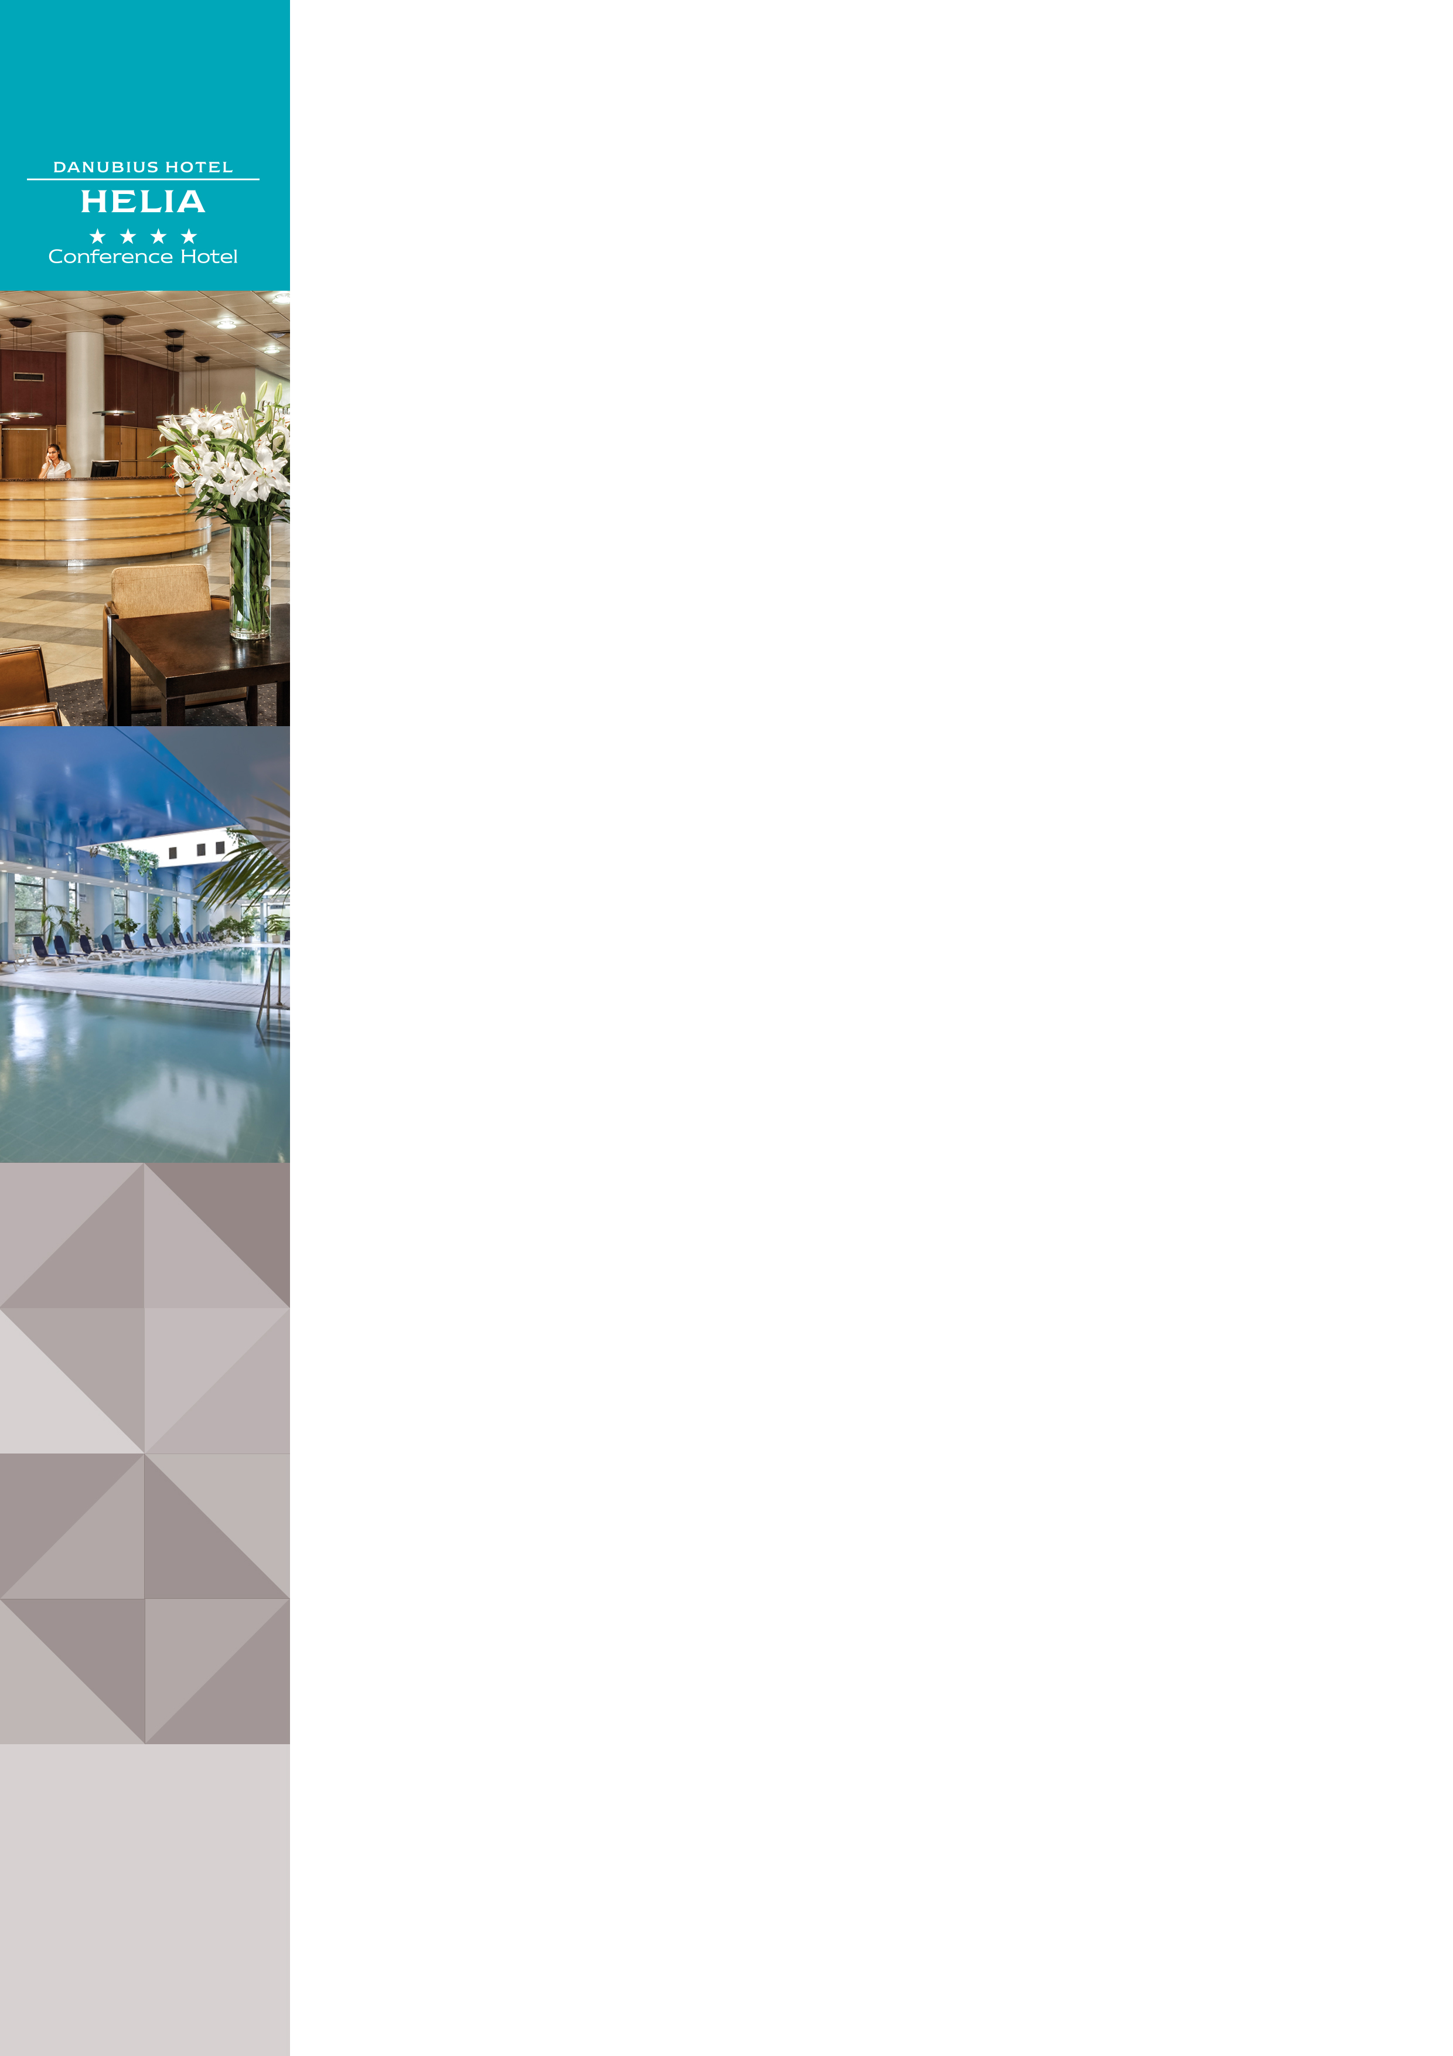Danubius Health Spa Resort Helia in Budapest

Address: |  |  | Danubius Health Spa Resort Helia ****, Kárpát utca 62-64., 1133 Budapest, Hungary
Website |  |  | www.danubiushotels.com/helia
Target group(s) |  |  | - City travellers  - Wellness guests  - Business travellers
Special features |  |  | - Hotel with own wellness centre  - Situated on the Danube riverbank
Star-based rating |  |  | **** 4 stars
Year of construction/latest renovation |  |  | 1990/ continuous
CONTACT
E-mail |  |  | helia.reservation@danubiushotels.com
Reception phone number |  |  | +36 1 889 5825
Point of contact in the case of problems |  |  | +36 1 889 5825
Spa department phone number: |  |  | +36 1 889 5820
Conference centre phone number |  |  | +36 1 889 5919
OVERVIEW
WiFi |  |  | Free in the entire hotel.
Reception opening hours |  |  | 0 – 24
Location |  |  | - from Liszt Ferenc airport, 30 minutes by taxi (22 km)  - from Budapest-Nyugati railway station, 10 minutes by taxi (2 km)  - from Budapest-Keleti railway station, 20 minutes by taxi (9 km)
Distance from Budapest city centre |  |  | The city centre is 15 minutes by taxi (5 km)
Public transport |  |  | - The Dózsa György út (M3) metro station is 11 minutes on foot (900 m)  - The Vág utca trolley bus stop (Bus 75) is 2 minutes on foot (140 m)  - The Dráva utca bus stop (Bus 115) is 4 minutes on on foot (350 m)
Parking |  |  | Parking lot in front of the hotel subject to fee: EUR 10 per day
Pets are welcome |  |  | Yes, EUR 20 per day
Currency exchange |  |  | No
Car and bike rental |  |  | No
ROOMS
Total number of rooms |  |  | 262
Single rooms (included DR for single use) |  |  | 262
Rooms for disabled guests |  |  | Yes, 5 rooms
Anti-allergy rooms |  |  | No
Non-smoking rooms |  |  | Yes
Check-in & Check-out |  |  | Check-in time: 14:00  Check-out time: 12:00
Hotel rooms
Category 1 | Danubius Guestroom: 20m² twin or double room, the city (Pest side)  Room amenities: air-conditioning, soundproof windows, bathroom with bathtub, hair dryer, bathrobe, safe deposit box, minibar, tea/coffee maker, TV with cable channels, radio channels and alarm function, wake up call, room service, telephone, free WiFi. On request: extra bed for children.
Category 2 | Deluxe Double Room: 20m² twin or double room overlooking the River Danube, Margaret Island (Margitsziget) and Buda Hills.  Room amenities: air-conditioning, soundproof windows, bathroom with bathtub, hair dryer, bathrobe, safe deposit box, minibar, tea/coffee maker, TV with cable channels, radio channels and alarm function, wake up call, room service, telephone, free WiFi. On request: extra bed for children.
Category 3 | Deluxe Room with Balcony: 20m² twin or double room overlooking the River Danube, Margaret Island (Margitsziget) and Buda Hills.  Room amenities: air-conditioning, soundproof windows, bathroom with bathtub, hair dryer, bathrobe, safe deposit box, minibar, tea/coffee maker, TV with cable channels, radio channels and alarm function, wake up call, room service, telephone, free WiFi. On request: extra bed for children. A limited number of connecting rooms are available.
Category 4 | Suite: 40m² suites are either business suites or come with a private sauna overlooking the River Danube, Margaret Island (Margitsziget) and Buda Hills. Rooms with a living room and a separated bedroom. The living room has a pull-out sofa and additionally the adjacent deluxe room can be connected to the suite to accommodate larger families.  Room amenities: air-conditioning, soundproof windows, balcony, bathroom with bathtub, private sauna and shower (suite with sauna) or with bathtub and bidet (business suite), hair dryer, bathrobe, safe deposit box, minibar, tea/coffee maker, TV with cable channels, radio channels and alarm function, wake up call, room service, telephone, free WiFi.
SPA & WELLNESS
Thermal water |  | - The natural thermal water is pumped from the nearby Margaret island to the hotel's health spa centre.  - Indications:  rheumatic diseases of the locomotive system, arthritis, gout, polyarthritis, ankylosing spondylarthritis, peritendinitis, lower back pain, post injury and post operative rehabilitation of joints and spine, fibromyalgia, respiratory catarrh, nervous disorders, geriatric regeneration.
Spa opening hours: |  | Mon - Sat 7:00 - 22:00
Facilities / water temperature |  | - Indoor swimming pool (26-28°C)  - 2 thermal pools (32-34°C) + (36-38°C)  - Gymnastics pool (34-36°C)  - Jacuzzi  - Steam cabin  - Sauna  - Infra-sauna  - Solarium  - Sun terrace  - Salt cave  - Cosmetics and hair salon
Services |  | - Own health spa centre  - Physiotherapy  - Budapest Retina Eye Clinic  - Wellness treatments  - Beauty treatments  - Fitness room, Aqua Jogging
Special features |  | Maitland manual therapy
DINING
Units/ opening hours |  | - Jupiter Restaurant (7:00 - 10:00, 12:00 - 15:00, 18:00 - 22:00) with live music  - Coffee Shops located:  in the Lobby (8:00 – 24:00)  at the poolside (8:00 - 22:00)  on the terrace (10:00 - 23:00)
Vegetarian/vegan dishes |  | Yes
Low-fat dishes |  | Yes
MEETINGS
Meeting and conference rooms |  | 12 conference and function rooms of various sizes with seating capacities of up to 400 people.
AWARDS
tripadvisor |  | - Certificate of Excellence 2015 Winner  - Cetrificate of Excellence 2013 Winner

