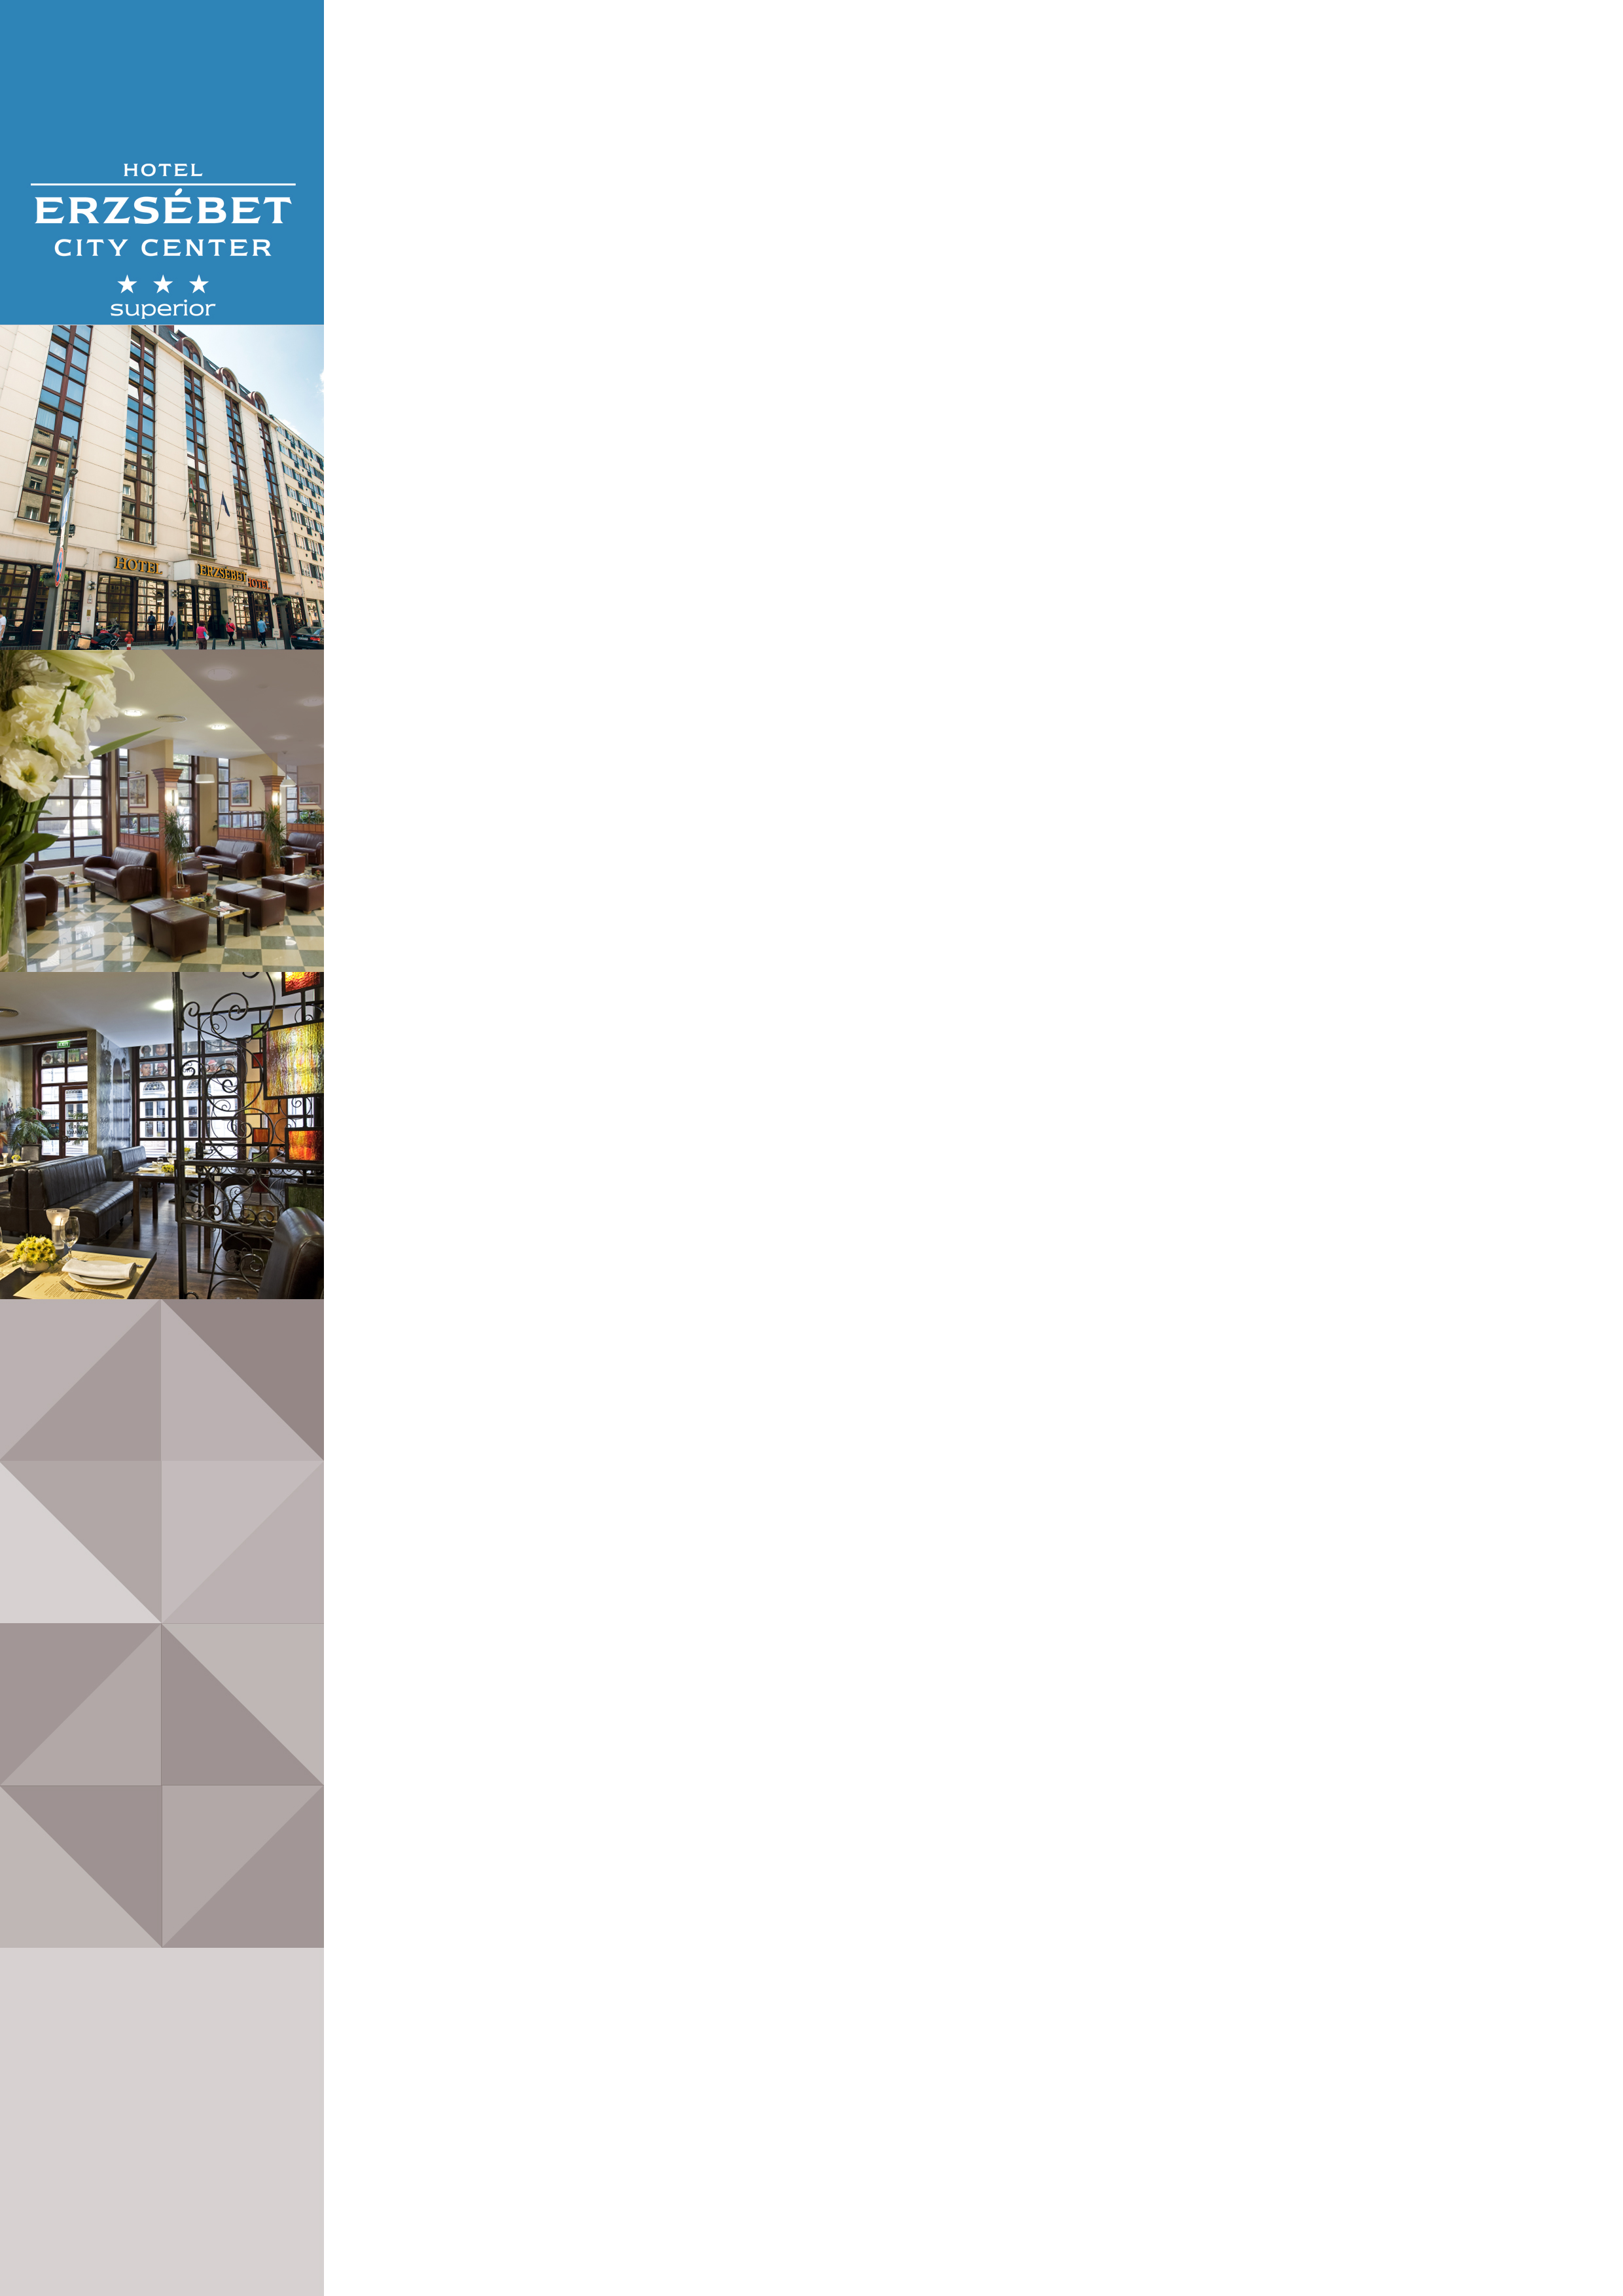Hotel Erzsébet City Center in Budapest

Address: |  |  |  | Hotel Erzsébet City Center *** Superior, Károlyi utca 11-15., 1053 Budapest, Hungary
Website |  |  |  | www.danubiushotels.com/erzsebet
Target group(s) |  |  |  | City travellers
Special features |  |  |  | Located in the Budapest city centre, close to the shopping streets
Star-based rating |  |  |  | *** 3 stars Superior
Year of construction/latest renovation |  |  |  | 1985 / 2008
CONTACT
E-mail |  |  |  | erzsebet.reservation@danubiushotels.com
Reception phone number |  |  |  | +36 1 889 3700
Point of contact in the case of problems |  |  |  | Mr. Balázs Réti – Front Office Manager
OVERVIEW
WiFi |  |  |  | Free in the entire hotel.
Reception opening hours |  |  |  | 0 – 24
Location |  |  |  | - from Liszt Ferenc airport, 30 minutes by taxi or shuttle bus (20 km)  - from Budapest-Keleti railway station, 10 minutes by taxi or by metro (3 km)
Distance from Budapest city centre |  |  |  | The hotel is located in the city centre
Public transport |  |  |  | - The Ferenciek tere bus stop is 2 minutes on foot (170 m)  - The Ferenciek tere (M3) metro station is 3 minutes on foot (200 m)
Parking |  |  |  | - The hotel does not have a dedicated parking lot  - Parking garage of the Franklin ház (Reáltanoda utca 5), discounted parking spaces (approx. 3 minutes on foot)
Pets are welcome |  |  |  | Yes, EUR 25 / night, depending on the pet's size
Currency exchange |  |  |  | No
Car and bike rental |  |  |  | Car rental
ROOMS
Total number of rooms |  |  |  | 123
Single rooms  Double or Twin |  |  |  | 7  108 (bed preferences upon availability)
Rooms for disabled guests |  |  |  | No
Anti-allergy rooms |  |  |  | No
Non-smoking rooms |  |  |  | Yes
Check-in & Check-out |  |  |  | Check-in time: 14:00  Check-out time: 11:00  Group Check-out: 10:00
Hotel rooms
Category 1 | Standard Twin Room: 15-19 m² twin bedded room stylishly arranged in warm, bright colours and comfortable furniture Room amenities: bathroom mostly with shower, soundproof windows, air conditioning, hair dryer, telephone, TV with satellite, minibar, wake up call, free WiFi.
Category 2 | Standard Double Room: 15-19 m² double room stylishly arranged in warm, bright colours and comfortable furniture.  Room amenities: bathroom mostly with shower, soundproof windows, air conditioning, hair dryer, telephone, TV with satellite, minibar, wake up call, free WiFi.  Standard Single: Single – bedded room overlooking the internal courtyard, with soundproof windows. Room size: 12.7m ²
Category 3
DINING
Units/ opening hours |  |  | Hotel guest’s buffet breakfast: between 07:00 and 10:00.  MészárSteak Kitchen Budapest is one of the best steak restaurant in the downtown, offers an imposing and price to value steak menu, workday lunch menu and á la carte menu which is available every day between 11:30 and 0:00, all this in a cozy, friendly atmosphere.  Judy’s Wine Bar: The cozy Wine Bar, that opens from the inside of the hall welcomes its wine-fancier guests every day between 12:00 and 0:00.  Other restaurants nearby: Guests can also dine at Danubius Hotel Astoria and Danubius Hotel Gellért, close to the Hotel.  Café Astoria & Restaurant in the Hotel Astoria is a 10-minute walk along Kossuth Lajos Street. The Café Astoria Restaurant spices up hospitality traditions with a 21st century approach and dynamism. It invites you to try out its creative cuisine and selection of contemporary refined gastronomic offerings.  At the foot of Gellért Hill, the Danubius Hotel Gellért offers great dining in two restaurants. The Panorama Restaurant, well known for its excellent food, has a spacious terrace that offers stunning views over the Danube and Budapest. You’ll find all the most popular Hungarian dishes on the menu, while the wine list includes items from several renowned wineries. Budapest’s oldest brasserie, the renovated Gellért Brasserie will round off your culinary experience with a great selection of food and its fun-and-buzzing atmosphere. The culinary delights are complemented by craft beers and a selection of the best Hungarian wines. Besides an a la carte menu, the daily and weekly menus are also constantly varied to incorporate the freshest natural ingredients.
Vegetarian/vegan dishes |  |  | No
Low-fat dishes |  |  | No

