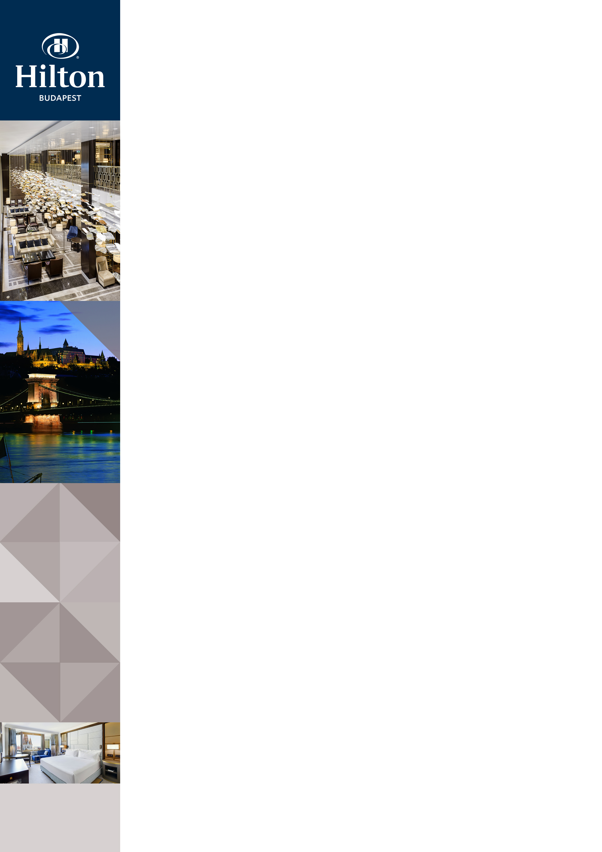Hilton Budapest

Address: |  |  |  | Hilton Budapest, Hess András tér 1-3., 1014 Budapest, Hungary
Website |  |  |  | www.danubiushotels.com/hilton
Target group(s) |  |  |  | - City travellers  - Business travellers
Special features |  |  |  | - Conference hotel  - Located immediately behind the Fisherman's Bastion  - The restored remains of a Dominican monastery are integrated into the hotel building  - Magnificent views to the Danube and the city
Star-based rating |  |  |  | No star-based rating, yet with 5-star services
Year of construction/latest renovation |  |  |  | 1976 / 2017
CONTACT
E-mail |  |  |  | sales.budapest@hilton.com
Reception phone number |  |  |  | +36 1 889-6600
Point of contact in the case of problems |  |  |  | Ms. Dorottya Kovács (dorottya.kovacs@hilton.com)
Conference centre phone number |  |  |  | +36 1 889 6908
OVERVIEW
WiFi |  |  |  | Free in the entire hotel.
Reception opening hours |  |  |  | 0 – 24
Location |  |  |  | - from Liszt Ferenc airport, 45 minutes by taxi (24 km)
Distance from Budapest city centre |  |  |  | The city centre is10 minutes by taxi (3 km)
Public transport |  |  |  | - The Szentháromság tér bus stop (Bus 16, 16A, 116, 916) is 2 minutes on foot (130 m)
Parking |  |  |  | - In order to preserve the Castle District, entrance into the Castle District is tied to a permit and is only available by a paying a parking fee.  - In the hotel's dedicated parking garage: HUF 9900/ day
Pets are welcome |  |  |  | Yes, EUR 30 / stay
Currency exchange |  |  |  | No
Car and bike rental |  |  |  | No
ROOMS
Total number of rooms |  |  |  | 322
Single rooms (included DR for single use) |  |  |  | 322
Rooms for disabled guests |  |  |  | Yes, 2 rooms
Anti-allergy rooms |  |  |  | No
Non-smoking rooms |  |  |  | Yes
Check-in & Check-out |  |  |  | Check-in time: 14:00  Check-out time: 12:00
Hotel rooms
Category 1 | King Guestroom: 31m² room with one King-sized bed, street and churchyard views.  Room amenities: air conditioning, bathroom with bathtub, hair dryer, HDTV, pay-per-view channels, cable channels, telephone, tea/coffee maker, minibar, safe deposit box, iron, ironing board, alarm clock, wake up call, room service.
Category 2 | King Danube View Room: 31m² room with one King-sized bed, view of the Danube.  Room amenities: air conditioning, bathroom with bathtub, hair dryer, HDTV, pay-per-view channels, cable channels, telephone, tea/coffee maker, minibar, safe deposit box, iron, ironing board, alarm clock, wake up call, room service.
Category 3 | Twin Guestroom: 31m² room with 2 Twin beds, street and churchyard views.  Room amenities: air conditioning, bathroom with bathtub, hair dryer, HDTV, pay-per-view channels, cable channels, telephone, tea/coffee maker, minibar, safe deposit box, iron, ironing board, alarm clock, wake up call, room service.
Category 4 | Twin Danube View Room: 31m² room with 2 Twin beds, view of the Danube.  Room amenities: air conditioning, bathroom with bathtub, hair dryer, HDTV, pay-per-view channels, cable channels, telephone, tea/coffee maker, minibar, safe deposit box, iron, ironing board, alarm clock, wake up call, room service.
Category 5 | King Executive Room: 31m² room with one King-sized bed, street and churchyard views, Executive Lounge access.  Room amenities: air conditioning, bathroom with bathtub and shower, hair dryer, HDTV, pay-per-view channels, cable channels, telephone, tea/coffee maker, minibar, safe deposit box, iron, ironing board, alarm clock, wake up call, room service.
Category 6 | King Executive Danube View Room: 31m² room with one King-sized bed, view of the Danube, Executive Lounge access. Room amenities: air conditioning, bathroom with bathtub and shower, hair dryer, HDTV, pay-per-view channels, cable channels, telephone, tea/coffee maker, minibar, safe deposit box, iron, ironing board, alarm clock, wake up call, room service.
Category 7 | Twin Executive Room: 31m² room with 2 Twin beds, street and churchyard views, Executive Lounge access.  Room amenities: air conditioning, bathroom with bathtub and shower, hair dryer, HDTV, pay-per-view channels, cable channels, telephone, tea/coffee maker, minibar, safe deposit box, iron, ironing board, alarm clock, wake up call, room service.
Category 8 | Twin Executive Danube View Room: 31m² room with 2 Twin beds, view of the Danube, Executive Lounge access.  Room amenities: air conditioning, bathroom with bathtub and shower, hair dryer, HDTV, pay-per-view channels, cable channels, telephone, tea/coffee maker, minibar, safe deposit box, iron, ironing board, alarm clock, wake up call, room service.
Category 9 | King Loft Suite: 55m² suite with a King-size bed, living room, kitchenette or an extra bathroom on the lower floor, street view.  Room amenities: air conditioning, bathroom with bathtub, hair dryer, HDTV, pay-per-view channels, cable channels, telephone, tea/coffee maker, minibar, safe deposit box, iron, ironing board, alarm clock, wake up call, room service.
Category 10 | King Danube View Junior Suite: 55m² corner Suite with a King-sized bed, living room and view of the Danube.  Room amenities: air conditioning, bathroom with bathtub, hair dryer, TV, pay-per-view channels, cable channels, telephone, radio, tea/coffee maker, minibar, safe deposit box, iron, ironing board, alarm clock, wake up call, room service.
Category 11 | King Danube River Suite: 65m² corner suite with a King-sized bed, living room and view of the Danube.  Room amenities: air conditioning, bathroom with bathtub, hair dryer, TV, pay-per-view channels, cable channels, telephone, radio, tea/coffee maker, minibar, safe deposit box, iron, ironing board, alarm clock, wake up call, room service.
Category 12 | King Presidential Suite: 160m² suite with a King-sized bed, living room, kitchen, dining area and two bathrooms, Executive Lounge access.  Room amenities: air conditioning, bathroom with bathtub and shower, hair dryer, TV, pay-per-view channels, cable channels, telephone, radio, tea/coffee maker, minibar, safe deposit box, iron, ironing board, alarm clock, wake up call, room service.
SPA & WELLNESS
Spa opening hours: |  |  | Beauty Salon: Mon - Fri 13:00 - 19:00, Sat 9:00 - 17:00  Fitness Center 0-24
Facilities: |  |  | - Sauna  - Fitness room  - Beauty Salon  - Indoor tanning
Services |  |  | Massages
DINING
Units/ opening hours |  |  | - ICON Restaurant (Mon - Fri 7:00 - 10:30, 12:00 - 15:00, 18:00 - 23:00; Sat + Sun 7:00 - 11:00, 12:00 - 15:00, 18:00 - 23:00)  - Lobby Bar (8:00 - 1:00 )
Vegetarian/vegan dishes |  |  |  | No
Low-fat dishes |  |  |  | No
MEETINGS
Meeting and conference rooms |  | The widest range of meeting and break-out rooms in Budapest, with a capacity of 660.
Special features |  | Restored remains of a 13th-century Dominican cloister and monastery incorporated into the contemporary structure of the hotel. The church grounds and the monastery can host 30-300 sized banquets, receptions and open-air events.
AWARDS
 |  | Tripadvisor / Traveller’s Choice 2017-08-22

