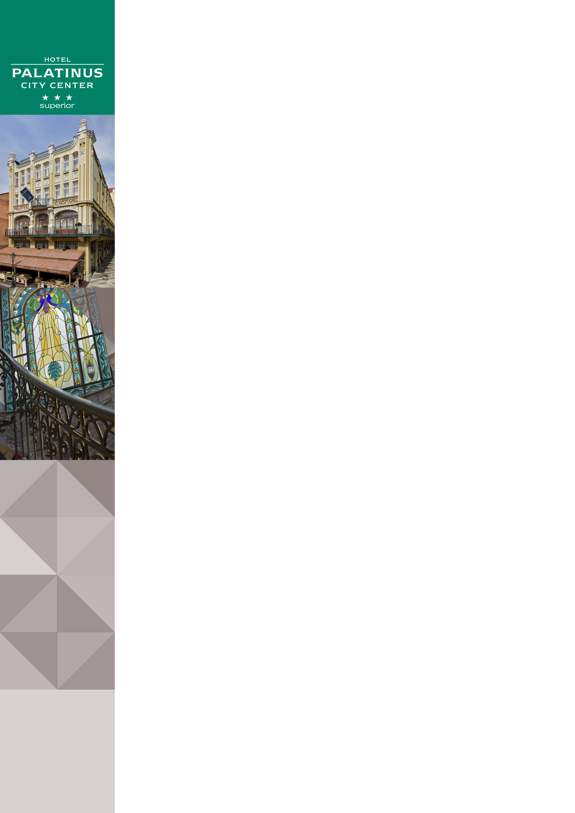Hotel Palatinus City Center in Pécs

Address: | Hotel Palatinus City Center***, Király utca 5., 7621 Pécs, Hungary
Website | www.danubiushotels.com/palatinus
Target group(s) | City travellers
Special features | A historical, Art Nouveau style building
Star-based rating | *** 3 stars
Year of construction/latest renovation | 1915/2002
CONTACT
E-mail | reservation.palatinus@danubiushotels.com
Reception phone number | +36 72 889 400
Point of contact in the case of problems | Ms. Anett Szabo Director of Sales and Marketing
OVERVIEW
WiFi | Free in the entire hotel.
Reception opening hours | 0 – 24
Location | - 5 minutes by taxi from the Pécs railway station (1.5 km)  - 2.5 hours from Budapest by car (220 km)
Distance from Pécs city centre | The hotel is located in the historical city centre
Public transport | - The railway station is 2 kms away  - Bus stop is 500 meters away
Parking | The hotel's dedicated parking garage: EUR 12 per night
Pets are welcome | Yes, EUR 10 per night
Currency exchange | No
Car and bike rental | No
ROOMS
Total number of rooms | 94
Single rooms (included DR for single use) | 94
Rooms for disabled guests | No
Anti-allergy rooms | Yes, 3 rooms
Non-smoking rooms | Yes
Check-in & Check-out | Check-in time: 14:00  Check-out time: 11:00
Hotel rooms
Category 1 | Economy Room: 15 – 21 m² rooms with twin beds on the 4th and 5th floors overlooking the pleasant neighbouring rooftops of the inner city.  Room amenities: bathroom with bathtub, TV with cable channels, telephone, radio, wake up call.
Category 2 | Standard Room: 17 – 25 m² rooms with a double bed or twin beds on the 2nd and 3rd floors facing the pedestrian street.  Room amenities: air conditioning, bathroom with bathtub, hair dryer, TV with cable channels, telephone, radio, kettle with coffee or tea supplies, minibar, wake up call.
Category 3 | Standard Suite: 32 + 21 m² Suites with a living room and a separate bedroom with a double bed or twin beds facing the pedestrian street. Ideal for families.  Room amenities: air conditioning, bathroom with bathtub, hair dryer, TV with cable channels, telephone, radio, kettle with coffee or tea supplies, minibar, wake up call.
SPA & WELLNESS
Spa opening hours: | Mon - Sat 13:00 - 20:00
Facilities: | - Sauna (free of charge)  - Steam bath
Services | Massages
DINING
Units/ opening hours | - Restaurant Palatinus (7:00 – 22:00)  - Terrace
Vegetarian/vegan dishes | Yes
Low-fat dishes | Yes, at request.
MEETINGS
Meeting and conference rooms | 3 conference and function rooms with seating capacities of up to 300 guests.

